GS-5500 and PSGS-5500 Series
Unmanaged GbE Switches
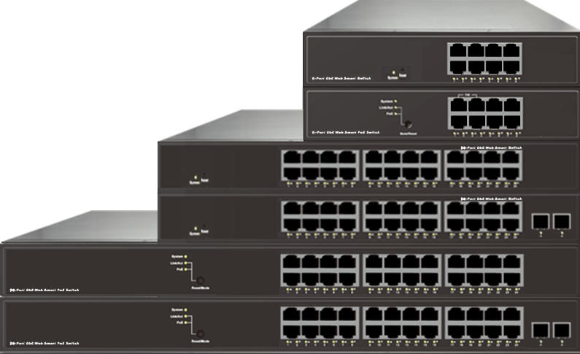

GS-5508

PSGS-5508NF

GS-5524

GS-5526

PSGS-5524L, PSGS-5524F

PSGS-5526L, PSGS-5526F
Overview
The GS-5500 and PSGS-5500 series unmanaged GbE switches are a plug-and-play Ethernet switches offering easy way to make the transition to Gigabit Ethernet and increase the speed of your network connection. The energy efficient, built to last, and rigorously tested provide the reliability businesses need.
The GS-5500 and PSGS-5500 series consist of 3 non-PoE models which are GS-5526, GS-5524 and GS-5508, and 5 PoE+ models which are PSGS-5526L, PSG-5526F, PSGS-5524L, PSGS-5524F and PSGS-5508NF. The series offer users with various options of port combinations and PoE+ budget, in order to meet different requirements in various applications.
Key Features
- IEEE 802.3u 100BASE-TX, 100Base-FX Fast Ethernet
- IEEE 802.3ab 1000Base-T Gigabit Ethernet
- IEEE 802.3z 1000Base-X Gigabit Fiber Ethernet
- IEEE 802.3az EEE Energy Efficient Ethernet standard for green Ethernet
- IEEE 802.3af/at Power over Ethernet

Benefits
- Lowing Total Cost of Ownership (TCO) with Energy-efficient Design
The switch is designed to help companies to save power needs and reduce TCO by Energy Efficient Ethernet (IEEE 802.3az). It can be used for customers to build a green Ethernet networking environment.

- Advanced Power over Ethernet Management
The model includes PoE+ options to power IP devices with power-saving features like Power scheduling and PoE configuration.
Specifications
Port Configuration
Model Name | Total Ports | RJ45 (10M/100M/1G) | Uplinks (100M/1G) | Console | Available PoE Power
GS-5526 | 26 | 24 | 2 SFP | -- | --
GS-5524 | 24 | 24 | -- | -- | --
GS-5508 | 8 | 8 | -- | -- | --
PSGS-5526L | 26 | 24 | 2 SFP | -- | 185W
PSGS-5526F | 26 | 24 | 2 SFP |  | 370W
PSGS-5524L | 24 | 24 | -- | -- | 185W
PSGS-5524F | 24 | 24 | -- | -- | 370W
PSGS-5508NF | 8 | 8 | -- | -- | 60W

Hardware Performance
Model Name | Forwarding Capacity (Mpps) | Switching  Capacity (Gbps) | Mac Table  (K) | Jumbo Frames  (Bytes)
GS-5526 | 38.688 | 52 | 8 | 9216
GS-5524 | 35.712 | 48 | 8 | 9216
GS-5508 | 11.904 | 16 | 8 | 9216
PSGS-5526L | 38.7 | 52 | 8 | 9216
PSGS-5526F | 38.7 | 52 | 8 | 9216
PSGS-5524L | 35.712 | 48 | 8 | 9216
PSGS-5524F | 35.712 | 48 | 8 | 9216
PSGS-5508NF | 11.904 | 16 | 8 | 9216

Environmental Range
Operating Temperature |  | Storage Temperature |  | Operating Humidity | Altitude
Fahrenheit | Centigrade | Fahrenheit | Centigrade | 10% to 90% non-condensing | Feet | Meters
32 to 122 | 0 to 50 | -4 to 158 | -20 to 70 |  | < 10000 | <3000

Dimension, Weights, Humidity
Model Name |  | Dimension (WxHxD) |  |  |  | Weight |  |  |  | Mounting Type
 |  | Millimeter |  | Inches |  | Kilograms |  | Pounds
GS-5526 | 280x44x166 |  | 11x1.7x6.5 |  | <2.5 |  | <5.5 |  | Desktop, Wall
GS-5524 | 280x44x166 |  | 11x1.7x6.5 |  | <2.5 |  | <5.5 |  | Desktop, Wall
GS-5508 | 220x44x134 |  | 8.6x1.7x5.3 |  | <1.5 |  | <3.3 |  | Desktop, Wall
PSGS-5526L | 442x44x211 |  | 17.4x1.7x8.3 |  | <3 |  | <6.6 |  | Desktop, Rack
PSGS-5526F | 442x44x211 |  | 17.4x1.7x8.3 |  | <3 |  | <6.6 |  | Desktop, Rack
PSGS-5524L | 442x44x211 |  | 17.4x1.7x8.3 |  | <3 |  | <6.6 |  | Desktop, Rack
PSGS-5524F | 442x44x211 |  | 17.4x1.7x8.3 |  | <3 |  | <6.6 |  | Desktop, Rack
PSGS-5508NF | 220x44x134 |  | 8.6x1.7x5.3 |  | <2 |  | <4.4 |  | Desktop, Wall

Voltage and Frequency
AC Input Voltage and Frequency
Voltage | 100-240 VAC
Frequency | 50~60 Hz

PoE Power Capacity
Model Name | Available PoE Power | Number of Ports That Support PoE(15.4W) and PoE+(30.0W)
PSGS-5526L | 185W | Each of port 1 - 24 support PoE/ PoE+ within available PoE Power
PSGS-5526F | 370W | Each of port 1 - 24 support PoE/ PoE+ within available PoE Power
PSGS-5524L | 185W | Each of port 1 - 24 support PoE/ PoE+ within available PoE Power
PSGS-5524F | 370W | Each of port 1 - 24 support PoE/ PoE+ within available PoE Power
PSGS-5508NF | 60W | Each of port 1 - 4 support PoE/ PoE+ within available PoE Power

Certifications
Electromagnetic Emissions (EMC)
CE, FCC Part 15 Class A

